ZENSE WEB DEVELOPMENT PROJECT DOCUMENTATION

Project objectives

Student side

This website ‘Learn Lingo’ provides a platform for students to gear up their English Grammar skills by giving different MCQ type quizzes on the grammar. After each quiz, his results will be displayed on the results page to track their mistakes. Each time a student attempts a quiz, he/she comes across a separate set of questions.

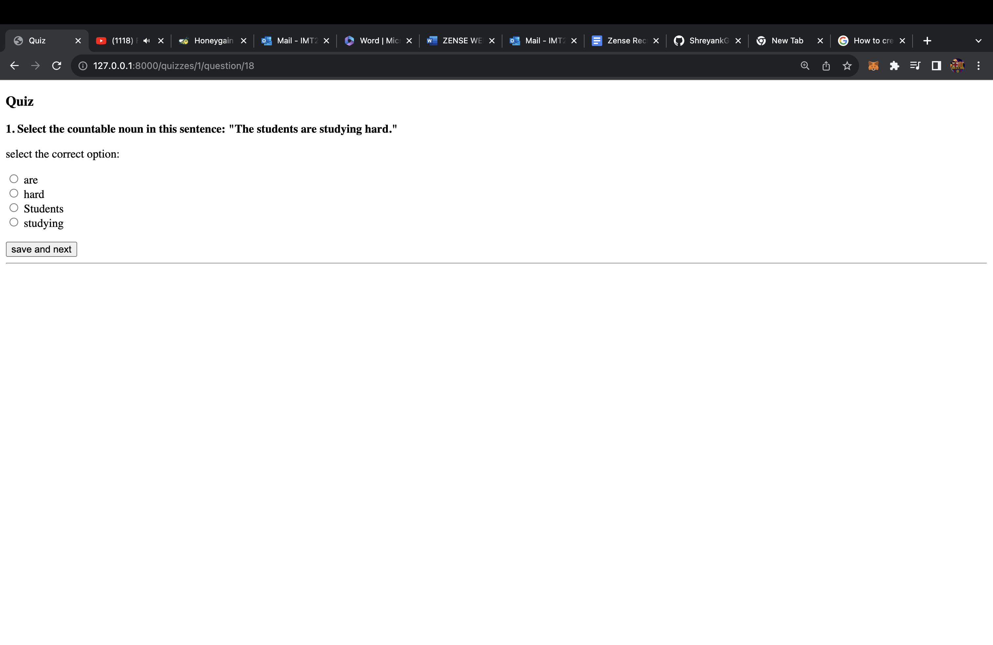

*The Credit System*: Each student has a Profile where he can see his credit score. The credit score is updated based on the percentage of marks in the quiz taken by the student. The more the credits, the more access to harder quizzes.

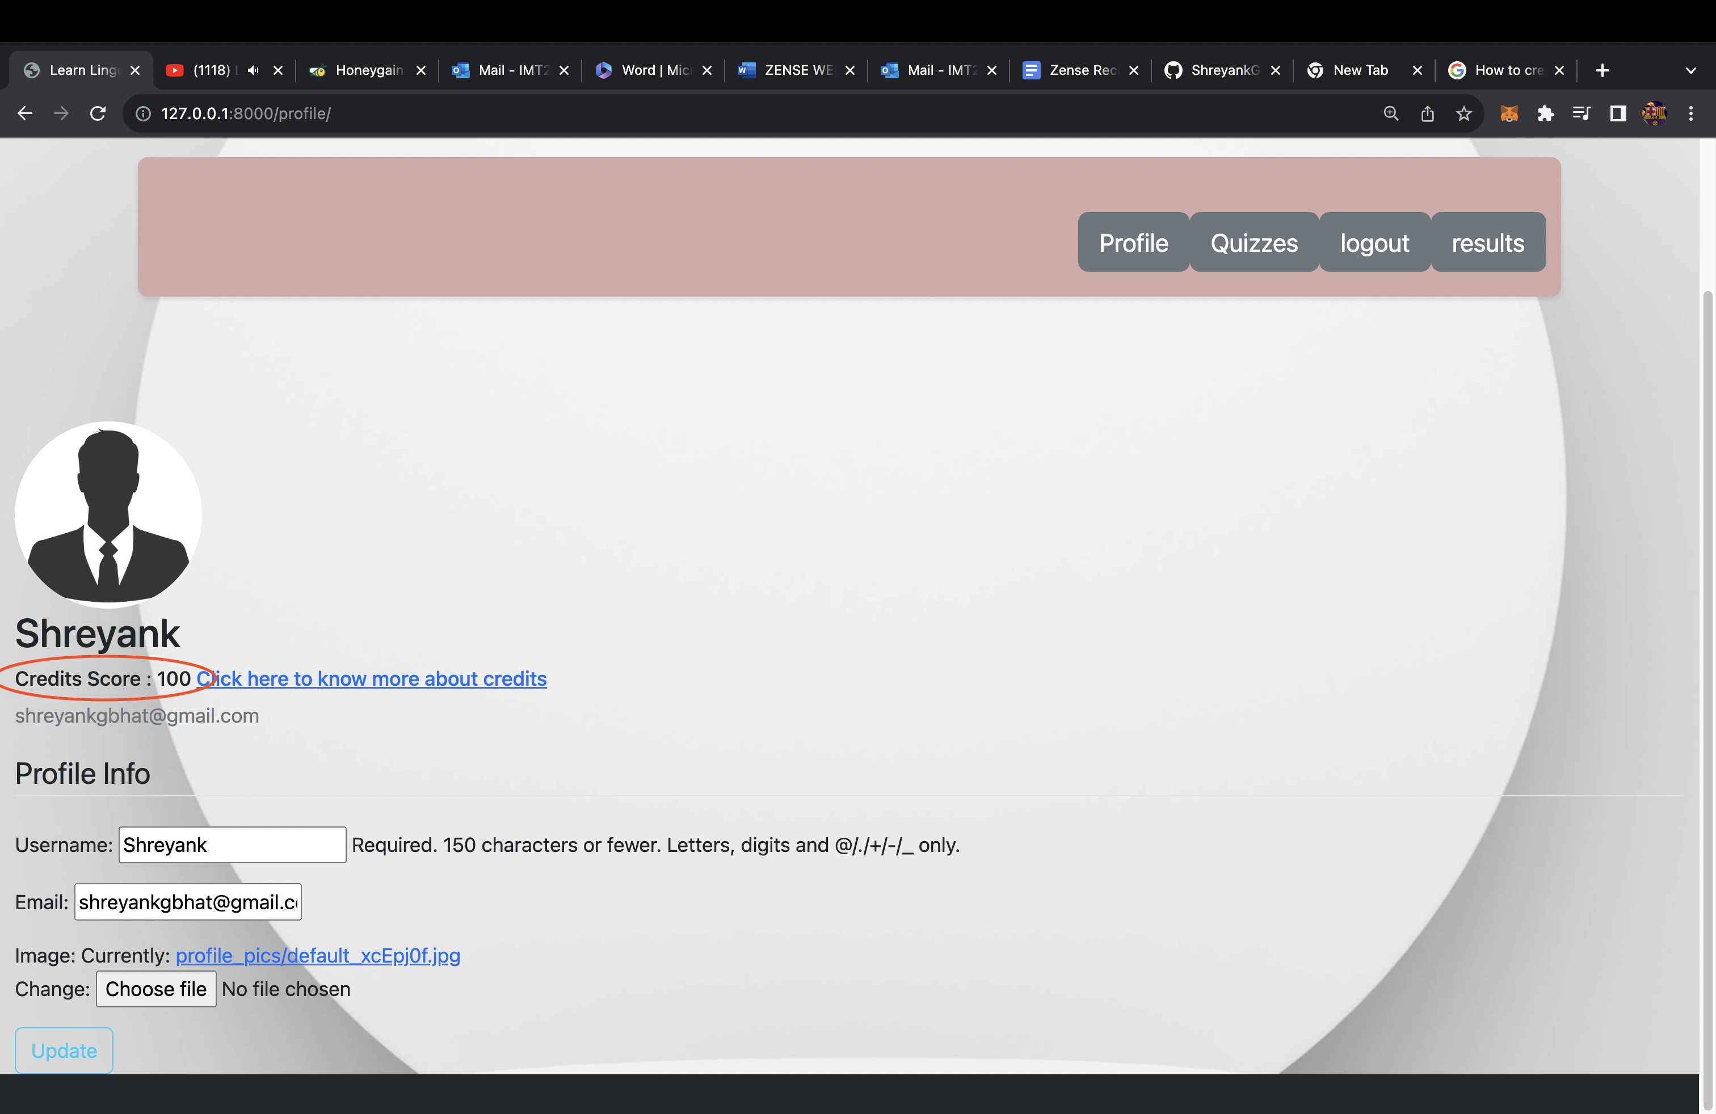

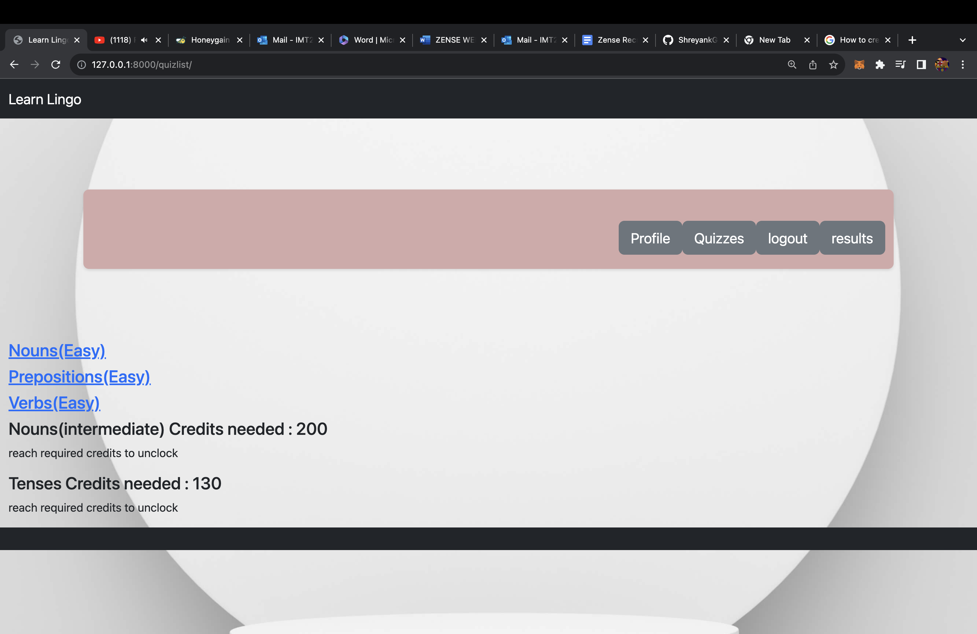

Teachers side

The teacher must have an email with the domain [‘@iiitb.com’](mailto:‘@iiitb.com’) in order to log in as a teacher. Each teacher registered on the website has the option to Create quizzes, set difficulty and cut off credit scores etc.

